Day in the Life of the Hudson River 10/13/22
Kaiser Park, Brooklyn
RIVER MILE: -8.5
Salt Front: ~RM 76
John Dewey High School – Wade Moody & Luis Gonzales
50 students & 5 adults
Latitude 40.5813°N & Longitude – 73.9994°W
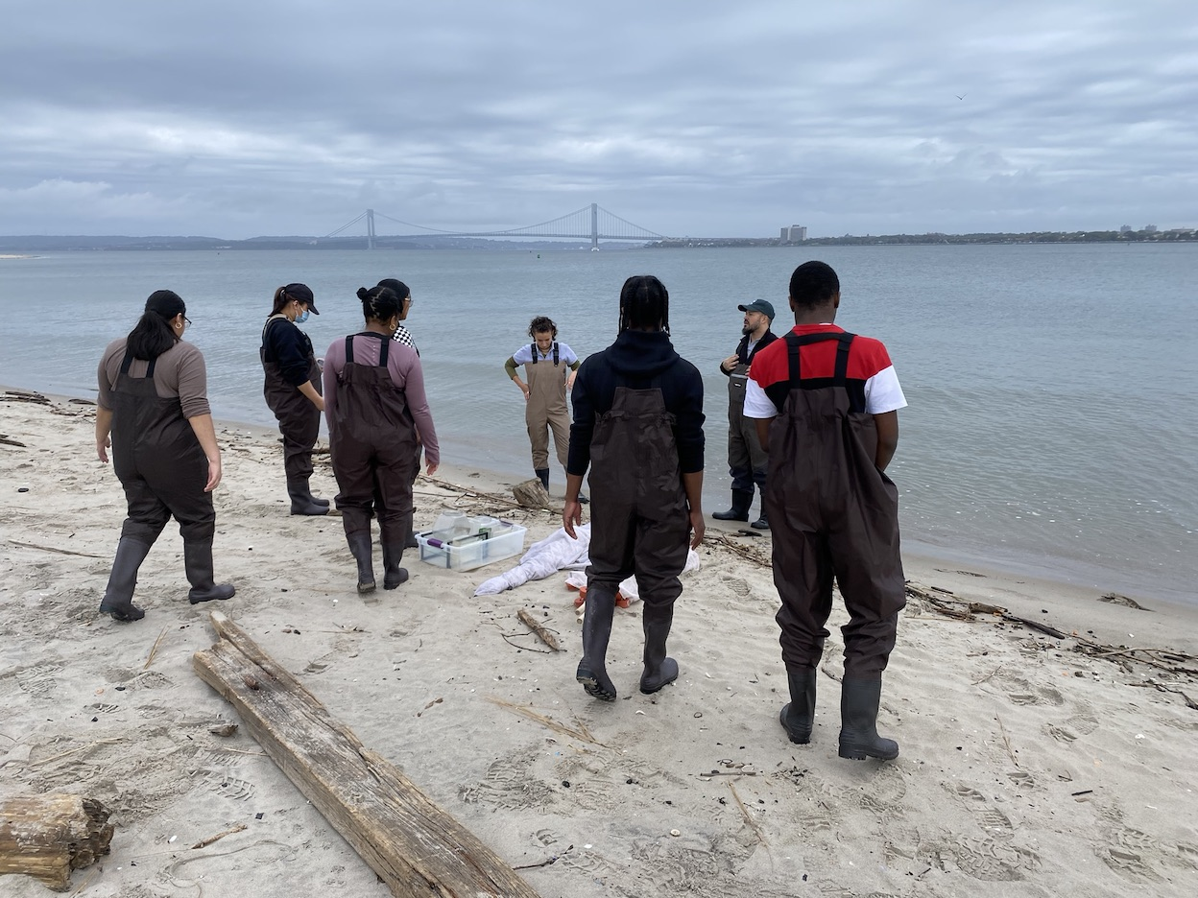 | 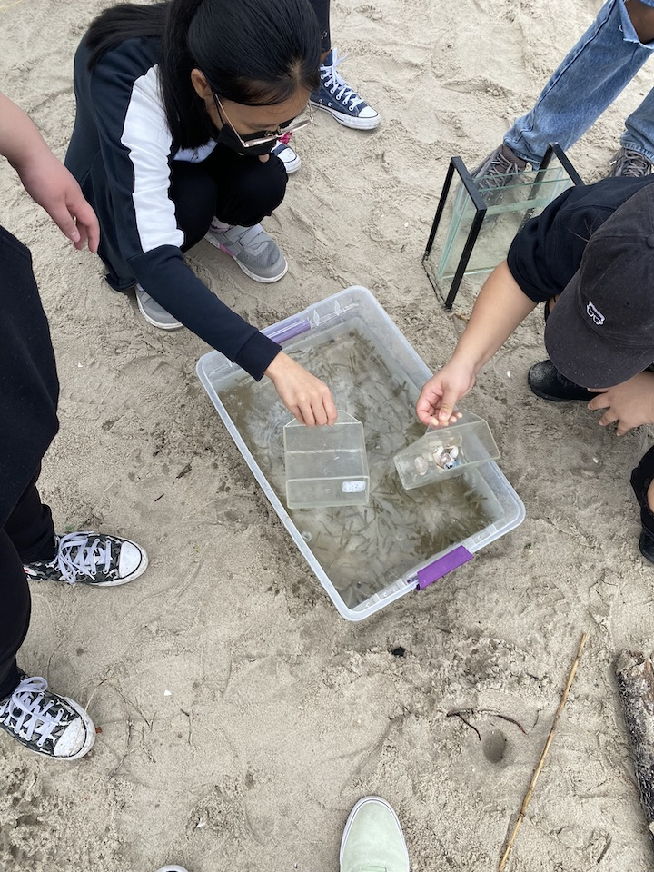 | 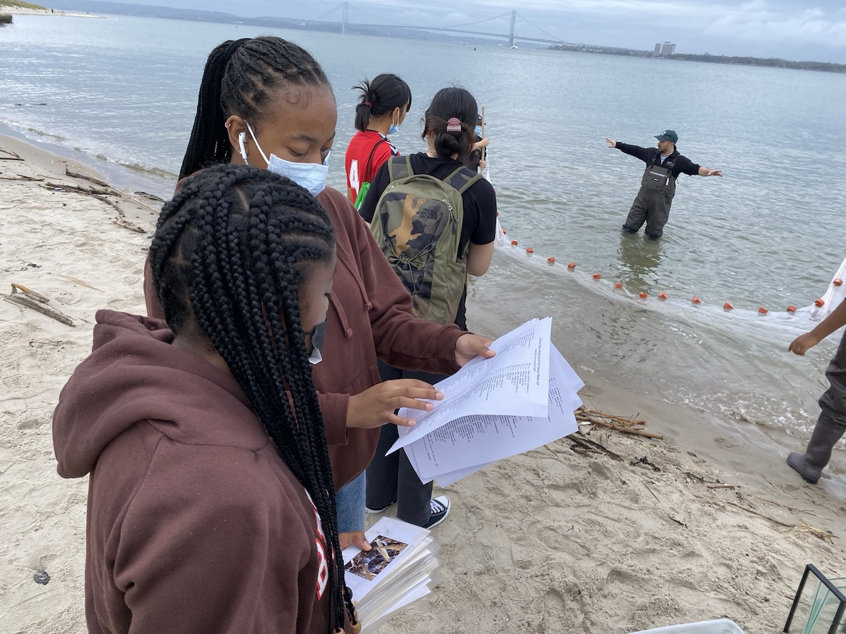

Location: Kaiser Park, Coney Island Creek, Brooklyn NY
Area: Forested, grassy
Sampling Site: Pier and wide beach area
Surrounding Land Uses: large beach, housing across roadway
Shoreline: sandy, muddy, rocky
River Bottom: sandy
Plants in the Water: No plants in the water
*NR = Not read/recorded
ITEM |  | Time |  | Reading |  |  |  | Comments
Physical
Air Temperature- |  | 11:15 AM |  | 18°C |  |  | 65°F
Wind Speed: NR |  |  |  | Anemometer |  |  | Beaufort | Direction
Weather today |  | NR |  | >75% cloud cover |  |  | Rained starting at 1pm
Weather the past 3 days: |  | Cool and dry
Tides- |  | Time |  | Rising, Falling, Unchanged |  |  | Water Height (cm)
 |  | All AM |  | Rising |  |  | NR
Current- NR |  | Time |  | Cm/sec |  | Knots | North/South | Ebb/Flood/Still
Water Temperature- NR
Turbidity- NR
Chemical
Salinity-NR
Standardized Salinity – Refractometer |  | 12:00 PM |  | 26,000 ppm
DO – Chemets Kit |  | Time  AM |  | Temp  NR |  |  | ppm DO  8 ppm | % saturation  NR
pH – NR
Nitrates- NR
Phosphates- NR
Alkalinity- NR
Biological-
Fish – Seine |  | Number |  | Name |  |  | Length of longest | Length of smallest
10:50 AM- 12:00 PM |  | 25 |  | Atlantic Silverside
Fish Totals |  | TOTAL:25 |  | Diversity: 1
Macroinvertebrates |  | Number |  | Name |  |  | Length of longest | Length of smallest
 |  | 3 |  | Long wrist hermit crab
Macroinvertebrate Totals |  | TOTAL: 3 |  | Diversity:1
Sediment Core - NA
Length NR | H2S smell |  | Oxid Top |  | Oil |  | Grain Size | Other Features
Boats-NA
 | Time |  | Name |  | Color |  | North/Southbound | Light/Loaded
Commercial NR
Recreational

